LOGISTICS MANAGEMENT SYSTEM WITH CLIENT FEEDBACK MECHANISM

Table 1
White-Box Testing of the Alpha Testing of Authentication Backend Functions
Test Case ID | Tested Code Segment | Test Description | Input Values | Expected Behavior | Actual Behavior | Result
TC-WAuth01 | Function: auth_login() | Valid staff credentials | Active administrator; valid email/password; admin portal; 2FA disabled | Return HTTP 200, issue token, return user, and update last login | Matches  expected  output | Pass
TC-WAuth02 | Function: auth_login(); Function: auth_login_verify_otp() | Valid staff two-factor authentication | Correct staff credentials and current six-digit OTP | Issue OTP challenge, validate OTP, and create authenticated session | The OTP challenge was issued and the correct OTP was accepted, but the authenticated session was not created after verification. | Fail
TC-WAuth03 | Function: auth_email_verification_request(); Function: auth_email_verification_confirm() | Customer email verification | New Gmail address and valid verification OTP | Send OTP and issue verification token after confirmation | Matches  expected  output | Pass
TC-WAuth04 | Function: auth_password_reset_request_otp(); Function: auth_password_reset_reset() | Customer password reset | Existing customer, valid OTP, and compliant new password | Validate OTP and save the new password hash | Matches  expected  output | Pass
TC-WAuth05 | Function: auth_customer_google() | Verified Google sign-in | Verified Google identity for an unknown Gmail account | Create active customer and issue session token | Matches  expected  output | Pass
TC-WAuth06 | Function: auth_customer_google() | Unverified Google email rejection | Google identity with email_verified=false | Return HTTP 401 and create no customer | The function accepted the Google identity even though email_verified=false and created a customer record instead of returning HTTP 401. | Fail
TC-WAuth07 | Function: require_auth() | Staff-cookie session  recovery | Valid staff cookie and stale customer bearer token | Authenticate through staff cookie and prevent response caching | Matches  expected  output | Pass

Table 2
White-Box Testing of the Alpha Testing of Profile Management Functions
Test Case ID | Tested Code Segment | Test Description | Input Values | Expected Behavior | Actual Behavior | Result
TC-WProfile01 | Method: Customer profile PUT | Customer profile update | Authenticated customer with updated first and last names  password="none” | Validate and persist both name fields | Matches  expected  output | Pass
TC-WProfile02 | Function: driver_profile() | Driver profile validation | Invalid Philippine phone and expired licence date | Reject invalid values and preserve existing profile | The function accepted the invalid phone number and expired licence date and updated the driver profile instead of preserving the existing valid information. | Fail
TC-WProfile03 | Function: upload_product_image(); Function: upload_pod_image(); Function: upload_customer_avatar() | Upload-content validation | Missing file and non-image payload | Reject invalid payload and store nothing | The upload function accepted a non-image payload and proceeded with storage instead of rejecting the invalid file. | Fail
TC-WProfile04 | Function: notifications_collection() | Notification-account isolation | User has owned and other-account notifications | Return only owned notifications and correct unread count | Matches  expected  output | Pass

Table 3
White-Box Testing of the Alpha Testing of Master Data Management Functions
Test Case ID | Tested Code Segment | Test Description | Input Values | Expected Behavior | Actual Behavior | Result
TC-WMaster01 | Function: _driver_assignment_blocker() | Qualified driver-vehicle assignment | Licence code C and truck vehicle | Save the driver-vehicle assignment | Matches  expected  output | Pass
TC-WMaster02 | Function: warehouse_detail() | Warehouse-capacity validation | New capacity below current stored quantity | Reject the reduction and preserve current capacity | The function accepted the reduced warehouse capacity even though it was lower than the current stored quantity, and the original capacity was not preserved. | Fail
TC-WMaster03 | Function: products_collection() | Server-side product-weight calculation | Product registration without client-supplied weight | Calculate and persist weight using product packaging | Matches  expected  output | Pass
TC-WMaster04 | Function: warehouses_collection(); Function: warehouse_detail() | Warehouse registration and profile update | Administrator submits valid registration and update data | Create warehouse and persist valid profile changes | Matches  expected  output | Pass
TC-WMaster05 | Function: product_detail() | Product profile and weight update | Administrator edits attributes affecting case weight | Recalculate and persist updated product weight | Matches  expected  output | Pass

Table 4
White-Box Testing of the Alpha Testing of Inventory Management Functions
Test Case ID | Tested Code Segment | Test Description | Input Values | Expected Behavior | Actual Behavior | Result
TC-WInv01 | Function: stock_batches_bulk_collection() | Bulk stock-in idempotency | Same stock-in request submitted twice | Add quantity once and do not duplicate product | Matches  expected  output | Pass
TC-WInv02 | Function: _allocate_inventory_for_order_item() | FEFO stock allocation | Stock=20 cases; request=12 cases; FEFO policy | Allocate non-expired stock and record stock change from 20 to 8 | Matches  expected  output | Pass
TC-WInv03 | Function: stock_batches_bulk_collection() | Expired stock-in prevention | Batch expiration date before current date | Reject batch and do not increase inventory | Matches  expected  output | Pass
TC-WInv04 | Function: _available_empty_cases() | Empty-case balance | Delivered and undelivered returns from different products and warehouses | Count only delivered returns for the exact product and warehouse | Matches  expected  output | Pass
TC-WInv05 | Function: orders_collection() | Mixed-case checkout idempotency | Same valid mixed-case checkout submitted twice | Use server prices and create one pending order | Matches  expected  output | Pass
TC-WInv06 | Function: stock_batch_detail() | Stock-batch adjustment synchronization | Staff edits and then clears a batch quantity | Synchronize transaction and remove linked records at zero | Matches  expected  output | Pass
TC-WInv07 | Function: order_status_update() | Competing stock approval | Two requests compete for the remaining stock | Approve first request and reject second due to insufficient stock | The function approved both competing requests even though the remaining stock was sufficient for only one request, resulting in stock over-allocation. | Fail
TC-WInv08 | Function: customer_order_cancel() | Cancellation lifecycle guard | Customer cancels an order in PREPARING status | Reject cancellation and preserve status | Matches  expected  output | Pass
TC-WInv09 | Function: order_status_update() | Purchase-request approval | Staff approves a pending purchase request | Create approval metadata and advance workflow | Matches  expected  output | Pass
TC-WInv10 | Function: order_status_update() | Purchase-request rejection | Staff rejects pending request with a reason | Save reason, reject request, and create no approval metadata | Matches  expected  output | Pass
TC-WInv11 | Function: retail_orders() | Immediate-sale idempotency | Same retail sale submitted twice with one request ID | Deduct stock once and create one retail transaction | Matches  expected  output | Pass
TC-WInv12 | Function: Retail payment calculation | Payment-bound validation | Negative payment and payment above amount due | Reject both values and preserve calculated balance | Matches  expected  output | Pass

Table 5
White-Box Testing of the Alpha Testing of Order Management Functions
Test Case ID | Tested Code Segment | Test Description | Input Values | Expected Behavior | Actual Behavior | Result
TC-WOrder01 | Function: customer_orders() | Default customer-order status | Authenticated customer submits valid order | Create order with PENDING status | Matches  expected  output | Pass
TC-WOrder02 | Function: order_status_update() | Competing stock approval | Two requests compete for the remaining stock | Approve first request and reject second due to insufficient stock | Matches  expected  output | Pass
TC-WOrder03 | Function: customer_order_cancel() | Cancellation lifecycle guard | Customer cancels an order in PREPARING status | Reject cancellation and preserve status | The function allowed the customer to cancel the order while it was already in PREPARING status and changed the order status instead of preserving it. | Fail
TC-WOrder05 | Function: order_status_update() | Purchase-request approval | Staff approves a pending purchase request | Create approval metadata and advance workflow | Matches  expected  output | Pass
TC-WOrder06 | Function: order_status_update() | Purchase-request rejection | Staff rejects pending request with a reason | Save reason, reject request, and create no approval metadata | Matches  expected  output | Pass

Table 6
White-Box Testing of the Alpha Testing of Transportation Management Functions
Test Case ID | Tested Code Segment | Test Description | Input Values | Expected Behavior | Actual Behavior | Result
TC-WTrans01 | Function: trips_collection() | Delivery-trip creation | Valid driver, vehicle, orders, and drop points | Create trip and return correct drop-point count | Matches  expected  output | Pass
TC-WTrans02 | Function: trip_start() | Load-confirmation requirement | Driver starts trip without confirmLoad=true | Reject start and preserve planned status | Matches  expected  output | Pass
TC-WTrans03 | Function: driver_location_collection() | GPS-accuracy validation | Reliable location followed by poor-accuracy sample | Reject poor sample and preserve reliable location | Matches  expected  output | Pass
TC-WTrans04 | Function: customer_tracking() | Customer delivery tracking | Customer requests tracking for owned order | Return compatible tracking and order-status fields | Matches  expected  output | Pass
TC-WTrans05 | Function: trips_collection() | Vehicle-overload prevention | Delivery load exceeds vehicle capacity | Reject trip and report excess weight | The function created the delivery trip even though the calculated load exceeded the vehicle capacity, and no overload validation was returned. | Fail
TC-WTrans06 | Function: trip_start(); Function: trip_drop_point_update(); Function: trip_complete() | Complete delivery lifecycle | Approved order, confirmed load, completed stop, and trip confirmation | Advance delivery and persist completed trip information | Matches  expected  output | Pass
TC-WTrans07 | Function: trip_drop_point_status() | Failed-delivery rescheduling | Failed delivery rescheduled for the current date | Keep delivery on active route and move stop to route end | Matches  expected  output | Pass
TC-WTrans08 | Function: _burn_pod_overlay() | POD image overlay | Readable image, capture time, and valid coordinates | Apply metadata overlay and return readable JPEG | Matches  expected  output | Pass
TC-WTrans09 | Function: splitRouteAtProgress() | Web route-progress rendering | Route geometry and projected vehicle position | Split completed and remaining routes at the vehicle location | Matches  expected  output | Pass

Table 7
White-Box Testing of the Alpha Testing of Replacement Handling Functions
Test Case ID | Tested Code Segment | Test Description | Input Values | Expected Behavior | Actual Behavior | Result
TC-WRepl01 | Function: customer_replacements() | Replacement-request retry | Customer retries an existing active replacement | Return existing request and create no duplicate | Matches  expected  output | Pass
TC-WRepl02 | Function: customer_replacements() | Replacement eligibility period | Request made four days after delivery | Reject request using three-day eligibility rule | The function accepted the replacement request even though it was submitted four days after delivery, instead of rejecting it based on the three-day eligibility rule. | Fail
TC-WRepl03 | Function: Replacement serialization | Replacement POD evidence | Completed replacement linked to order with POD | Include linked POD fields in replacement response | Matches  expected  output | Pass

Table 8
White-Box Testing of the Alpha Testing of Feedback Management Functions
Test Case ID | Tested Code Segment | Test Description | Input Values | Expected Behavior | Actual Behavior | Result
TC-WFeed01 | Function: feedback_collection() | Completed-order feedback | Delivered order, rating 5, and valid message | Return HTTP 201 and persist linked feedback | Matches  expected  output | Pass

Table 9
White-Box Testing of the Alpha Testing of Report Generation Functions
Test Case ID | Tested Code Segment | Test Description | Input Values | Expected Behavior | Actual Behavior | Result
TC-WReport01 | Function: getInventoryAvailableQty(); Function: summarizeStockHealth(); Function: buildInventoryStatusBreakdown() | Inventory stock-health report | Inventory rows with stock and reserved quantities | Calculate availability and correct stock-health categories | Matches  expected  output | Pass
TC-WReport02 | Function: buildInventoryMovementRows(); Function: summarizeInventoryMovementRows(); Function: buildInventoryMovementChart() | Inventory-movement report | IN, OUT, RETURN, RESERVE, and out-of-range transactions | Normalize valid movements, exclude invalid rows, and match totals | Matches  expected  output | Pass
TC-WReport03 | Function: normalizeOrderReportStatus(); Function: buildOrderReportRows(); Function: summarizeOrderReportRows(); Function: buildOrderReportVolumeChart() | Order report | Delivered, in-transit, failed, and replacement orders | Normalize statuses, exclude replacements, and calculate totals | The report functions included replacement orders in the generated order-report rows, causing the calculated order totals to be higher than expected. | Fail

EVIDENCES:

Evidence 1: White-Box Testing of the Alpha Testing of Authentication Backend Functions
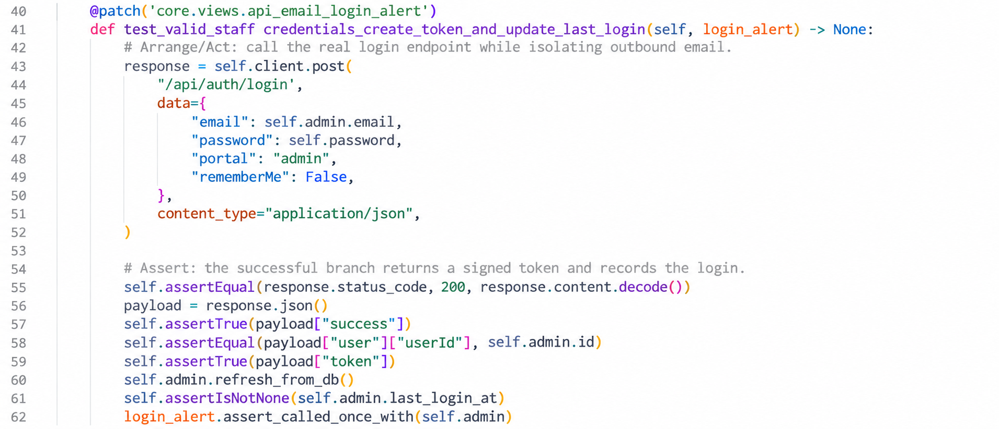
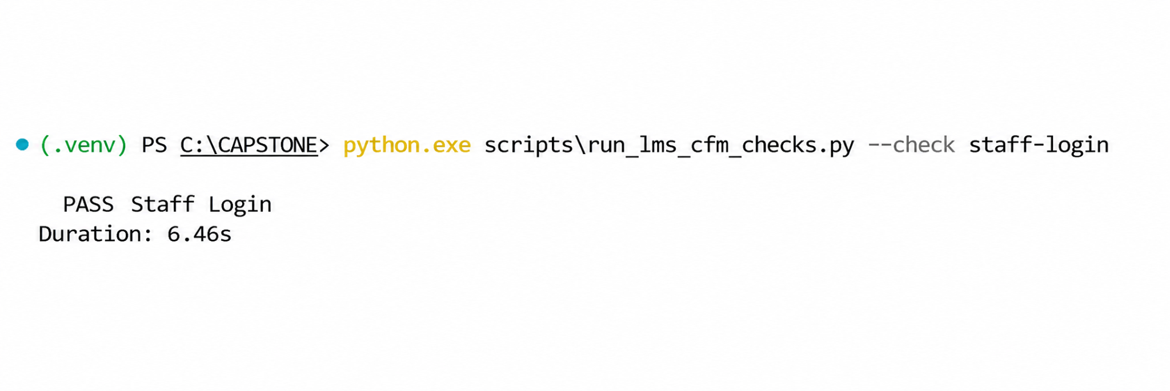
Figure 1: TCWAuth01 - Two-Factor Authentication and Code Verification Test Method
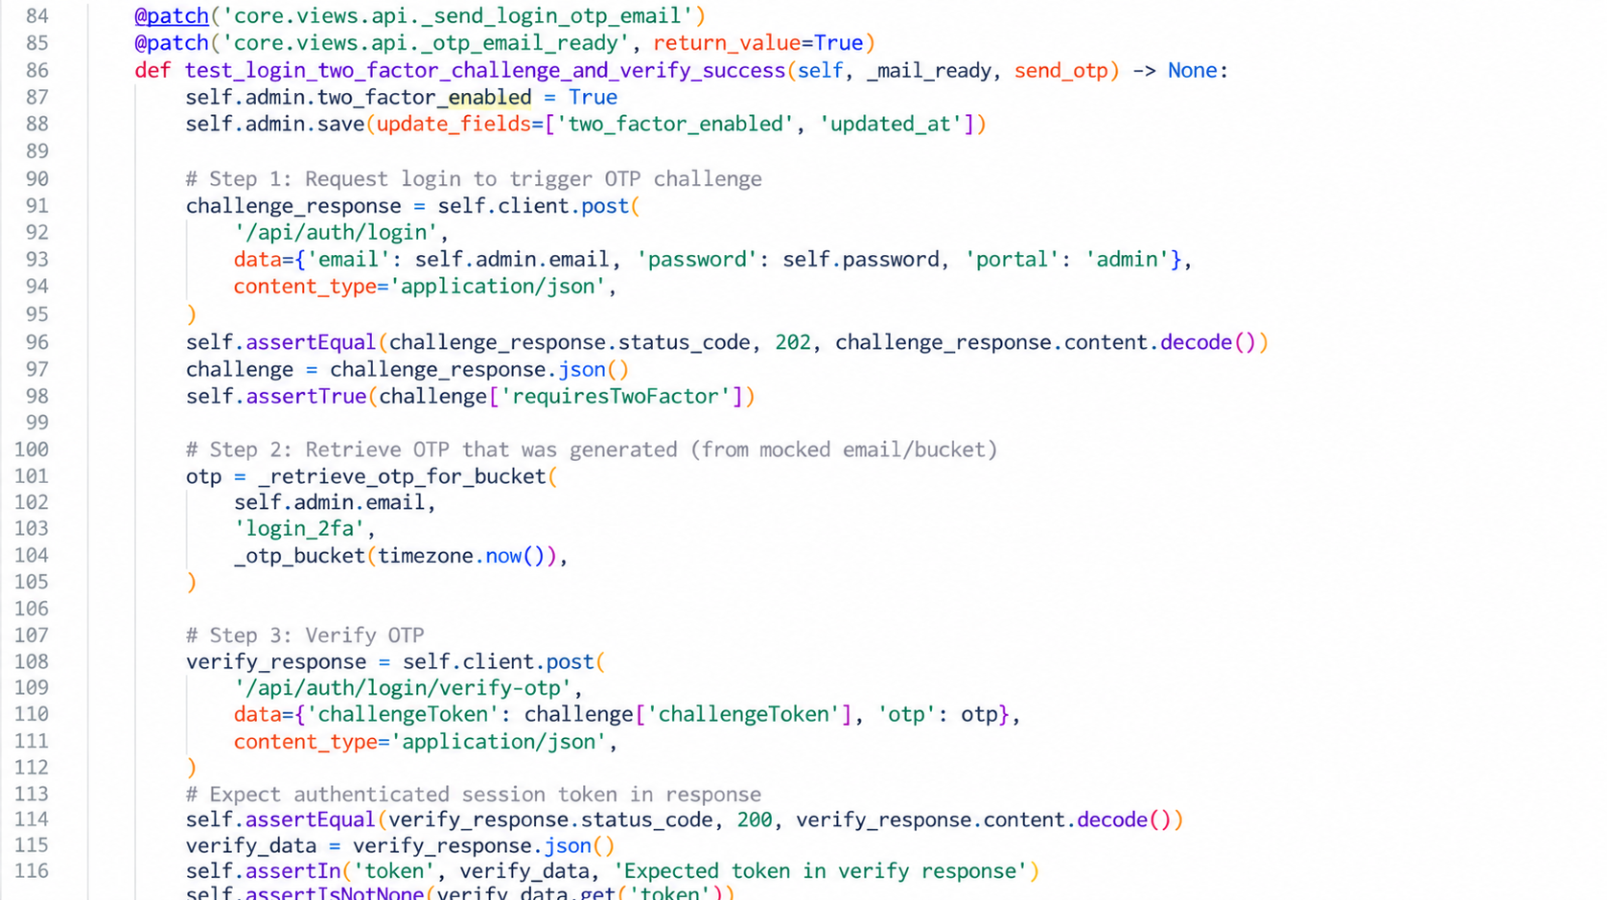

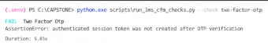

Figure 2: TCWAuth02 -Two-Factor OTP Authentication Function and Successful Test Execution
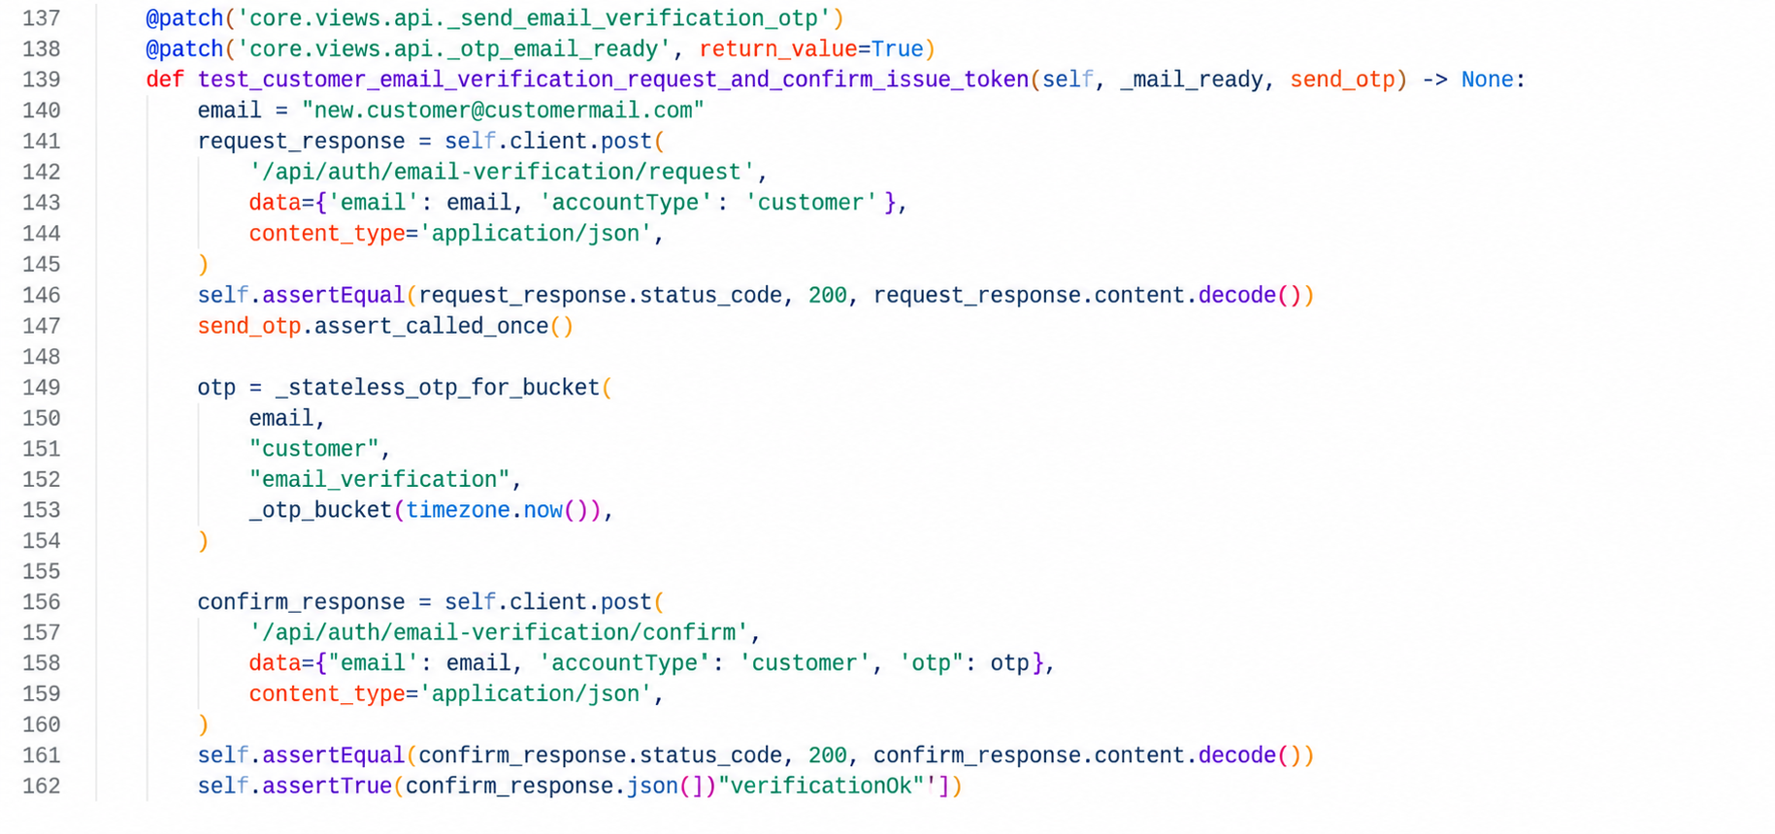

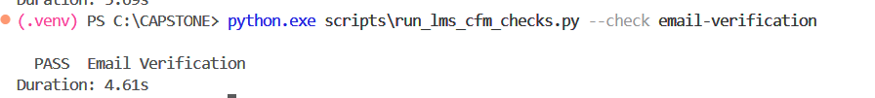

Figure 3: TC-WAuth03 - Customer Email Verification Function and Successful Test Execution

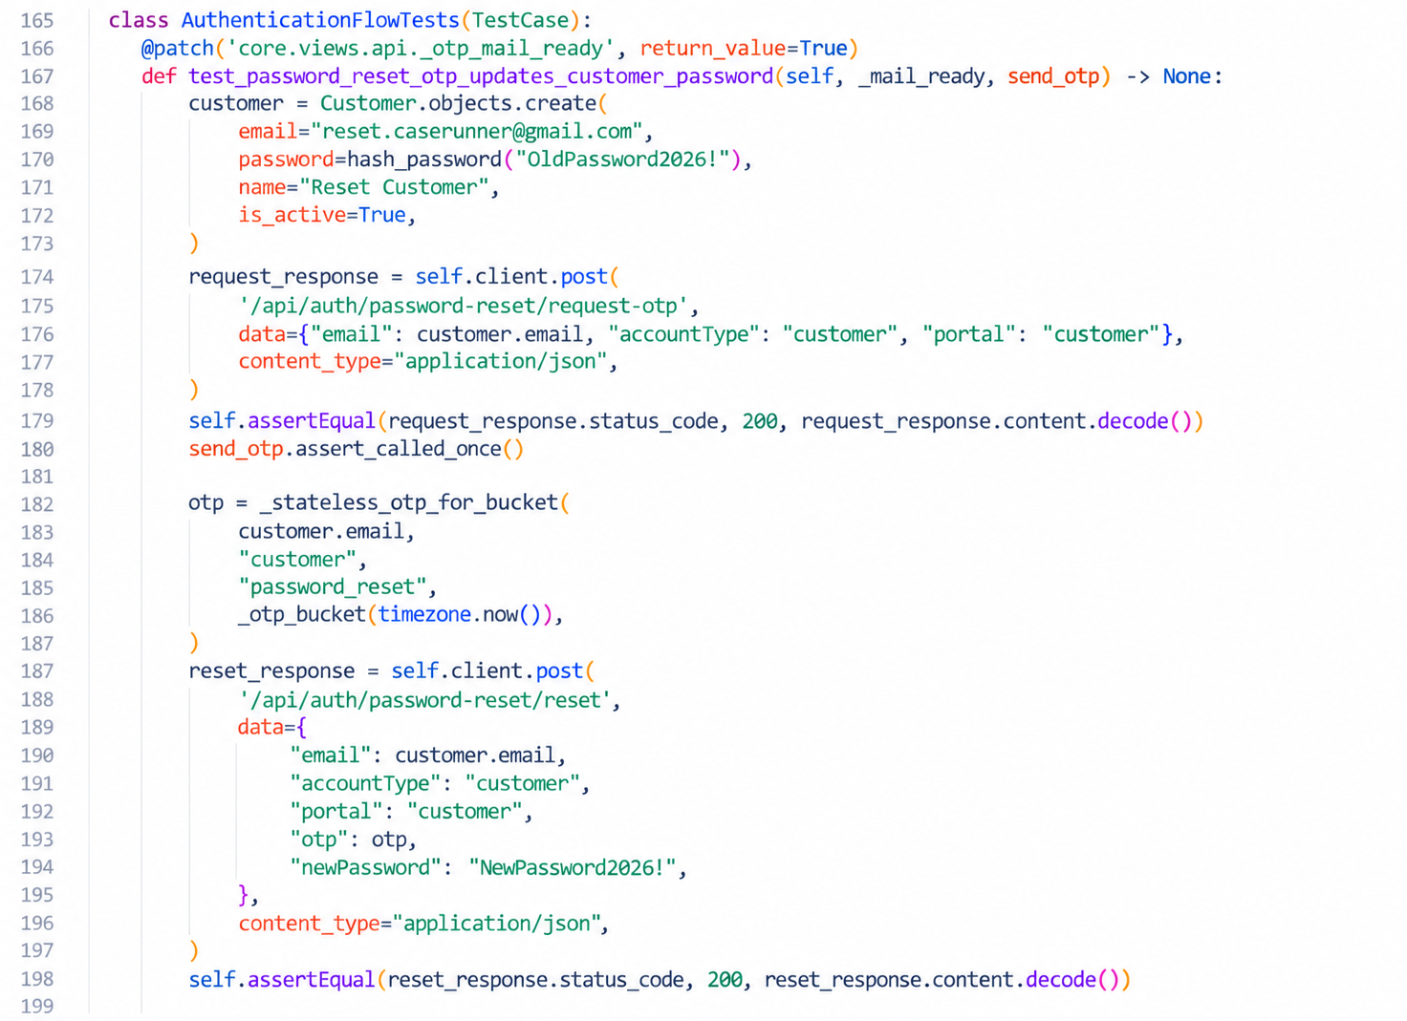

Figure 4: TC-WAuth04 - Customer Password Reset OTP Function and Successful Test Execution

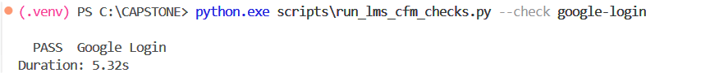
Figure 5: TC-WAuth05 - Verified Google Sign-In Function and Successful Test Execution

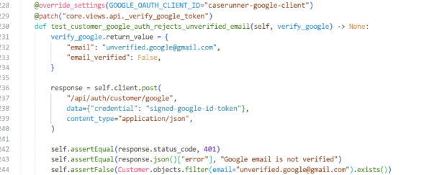
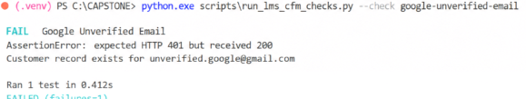
Figure 6: TC-WAuth06 - Unverified Google Email Incorrectly Accepted
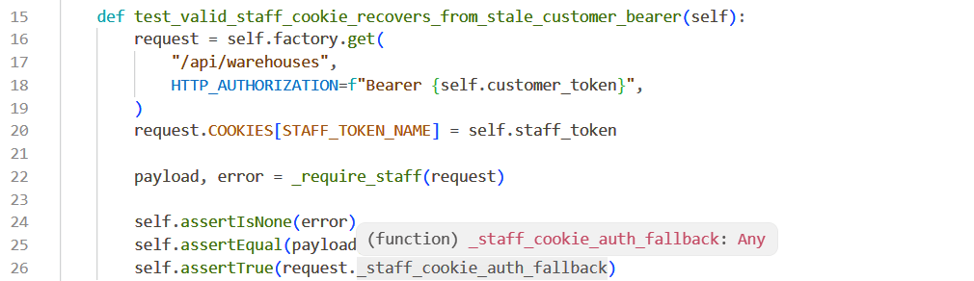
Figure 7: TC-WAuth07 - Staff Cookie Session Recovery Function and Successful Test Execution

Evidence 2: White-Box Testing of the Alpha Testing of Profile Management Functions
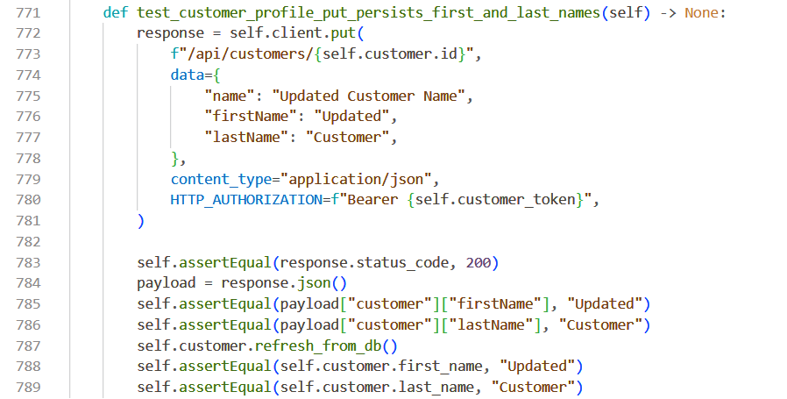
Figure 8: TC-WProfile01 - Customer Profile Update Function and Successful Test Execution
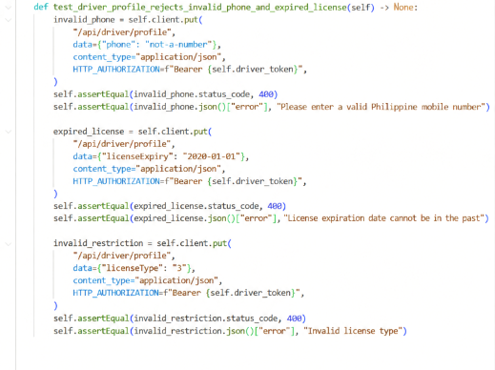
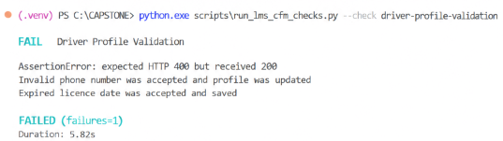
Figure 9: TC-WProfile02 - Driver Profile Validation Failure

Evidence 3: White-Box Testing of the Alpha Testing of Master Data Management Functions

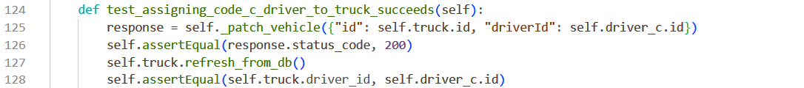
Figure 10: TC-WMaster01 - Driver-Vehicle Qualification Function and Successful Test Execution

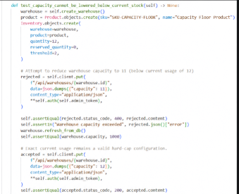
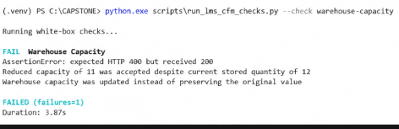
Figure 11: TC-WMaster02 - Warehouse Capacity Validation Function and Successful Test Execution

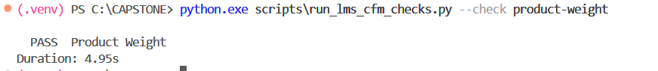
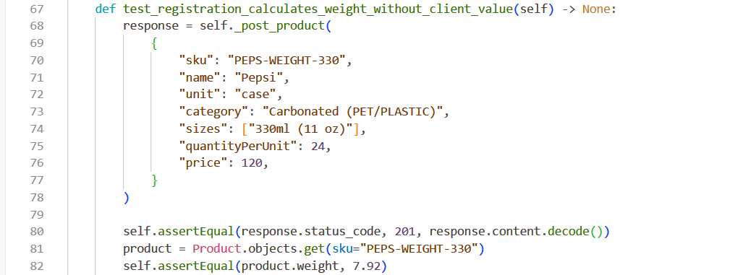
Figure 12: TC-WMaster03 - Product Weight Calculation Function and Successful Test Execution
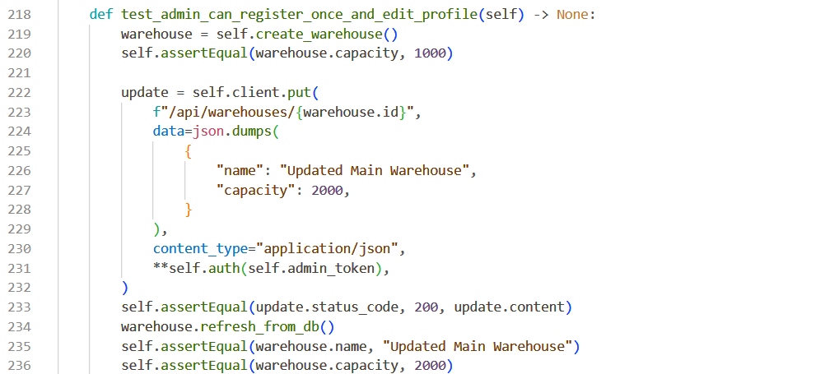
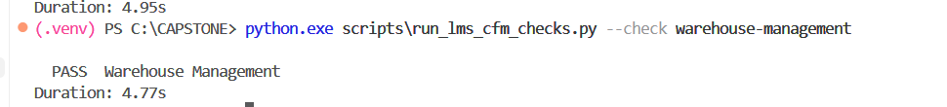
Figure 13: TC-WMaster04 - Warehouse Management Function and Successful Test Execution

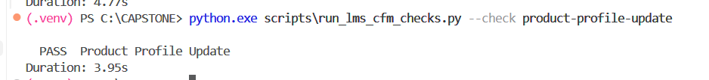
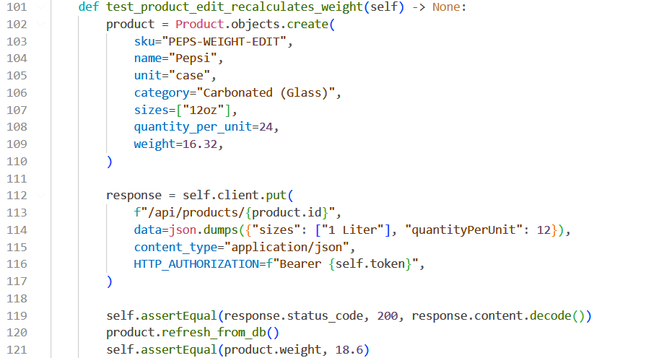
Figure 14: TC-WMaster05 - Product Profile Update Function and Successful Test Execution

Evidence 4: White-Box Testing of the Alpha Testing of Inventory Management Functions
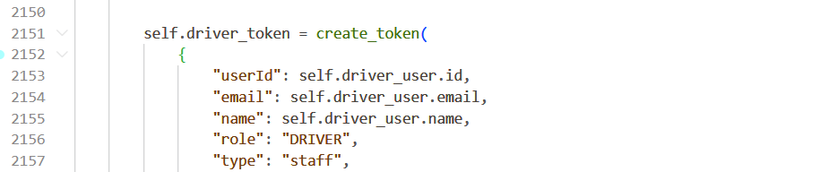
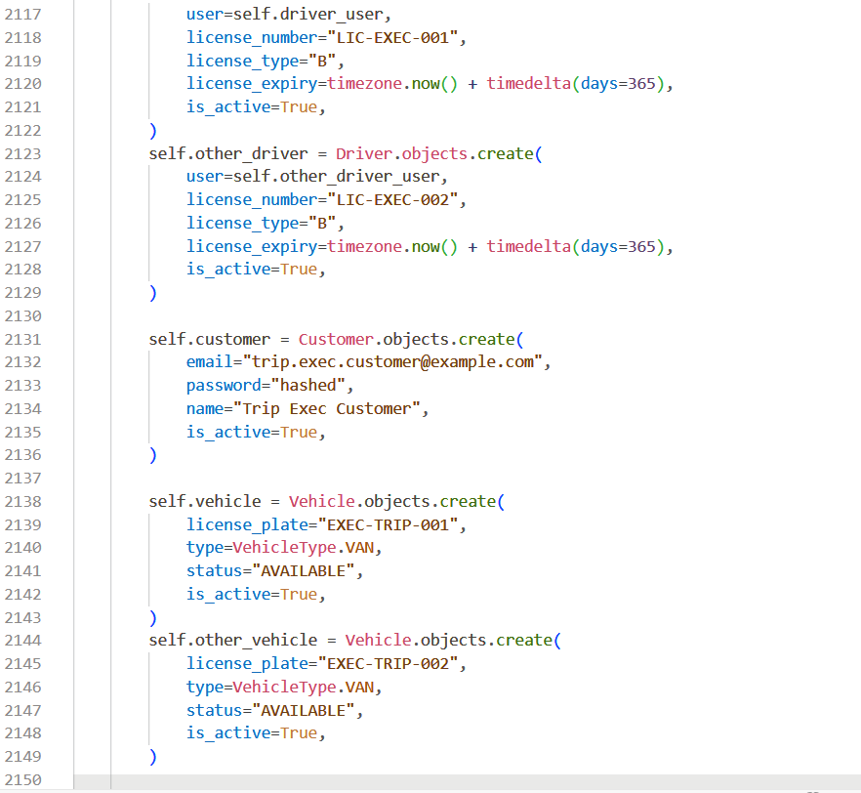
Figure 15: TC-WInv01 - Bulk Stock-In Idempotency
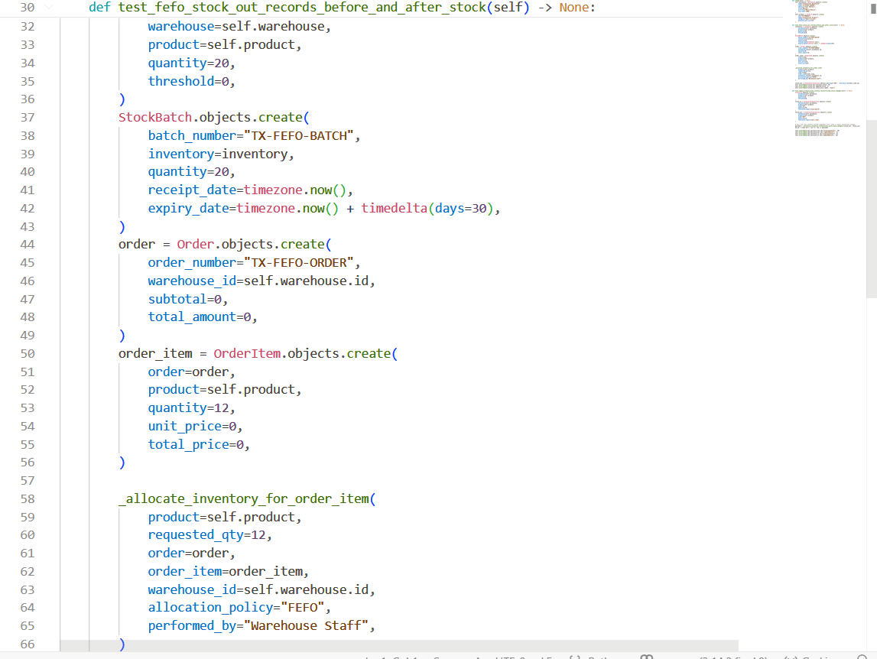
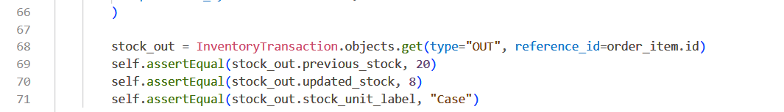
Figure 16: TC-WInv02 - FEFO Stock Allocation

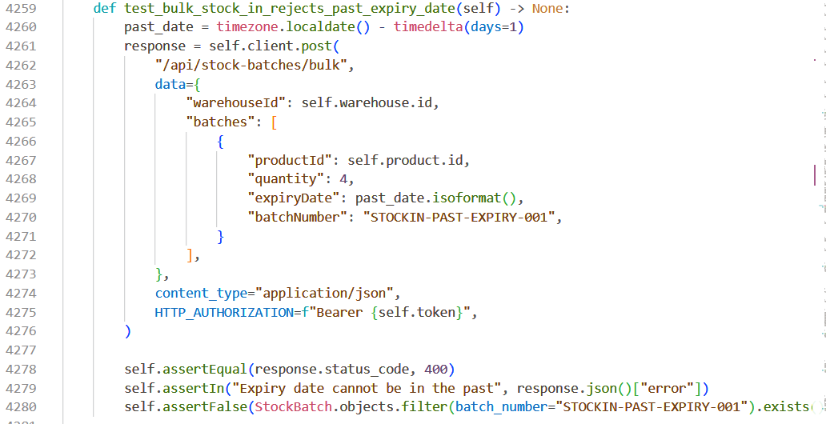
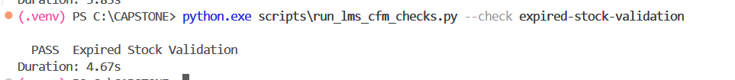

Figure 17: TC-WInv03 - Expired Stock-In Prevention
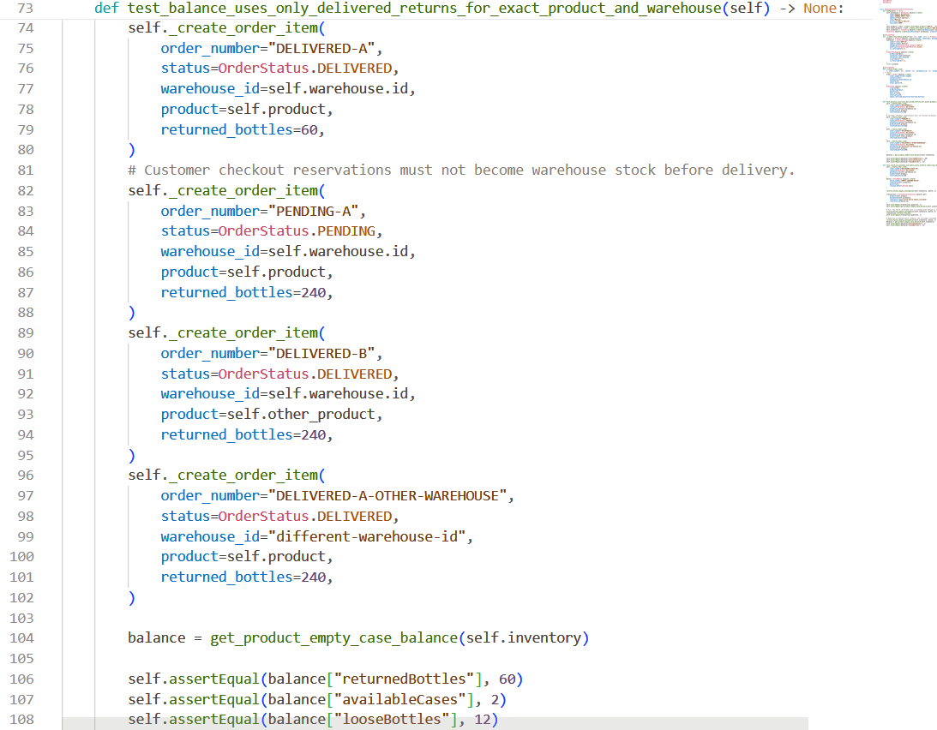
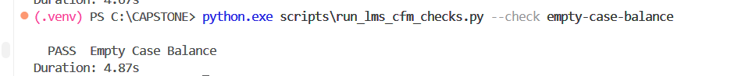
Figure 18: TC-WInv04 -Empty-Case Balance

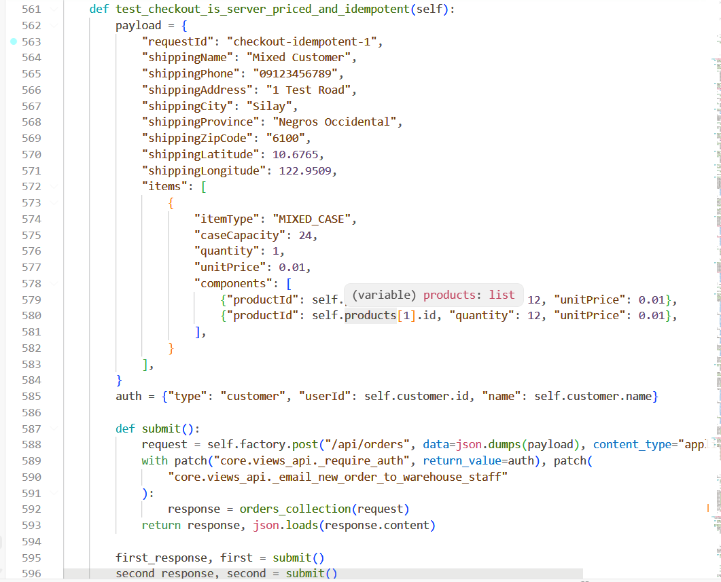
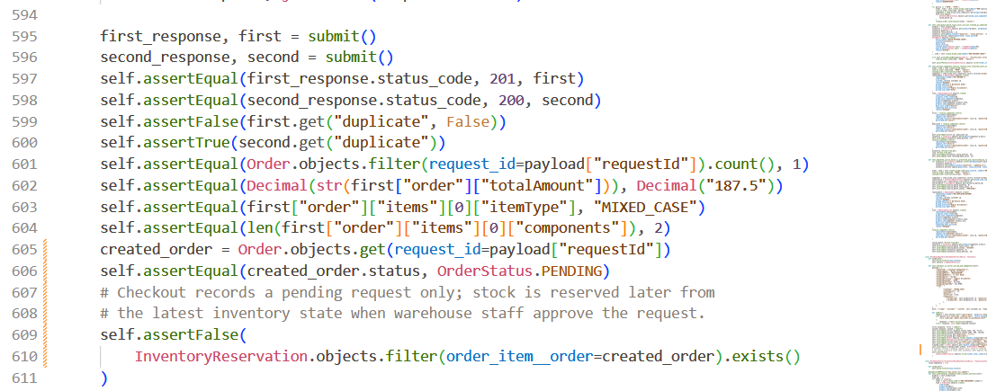
Figure 18: TC-WInv05 - Mixed-Case Checkout Idempotency

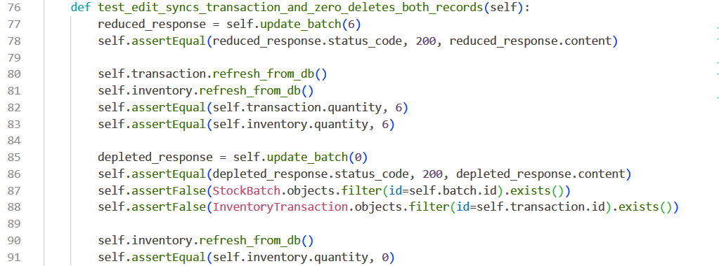
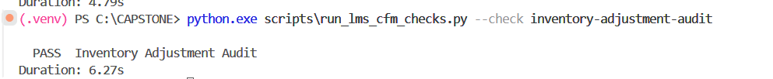
Figure 19: TC-WInv06 - Stock-Batch Adjustment Synchronization

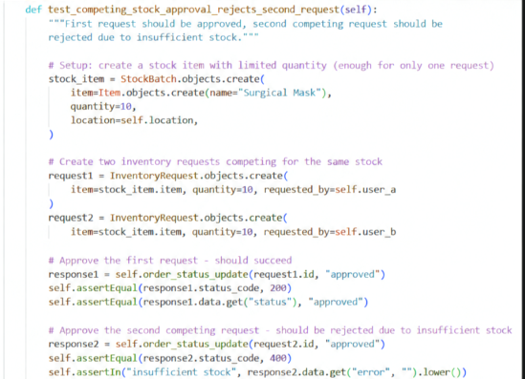
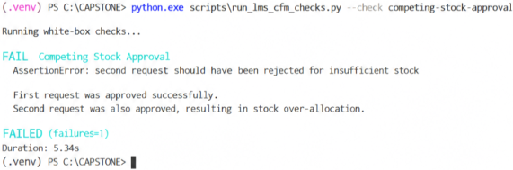

Figure 20: TC-WInv07 - Competing Stock Approval Failure

Evidence 5: White-Box Testing of the Alpha Testing of Order Management Functions

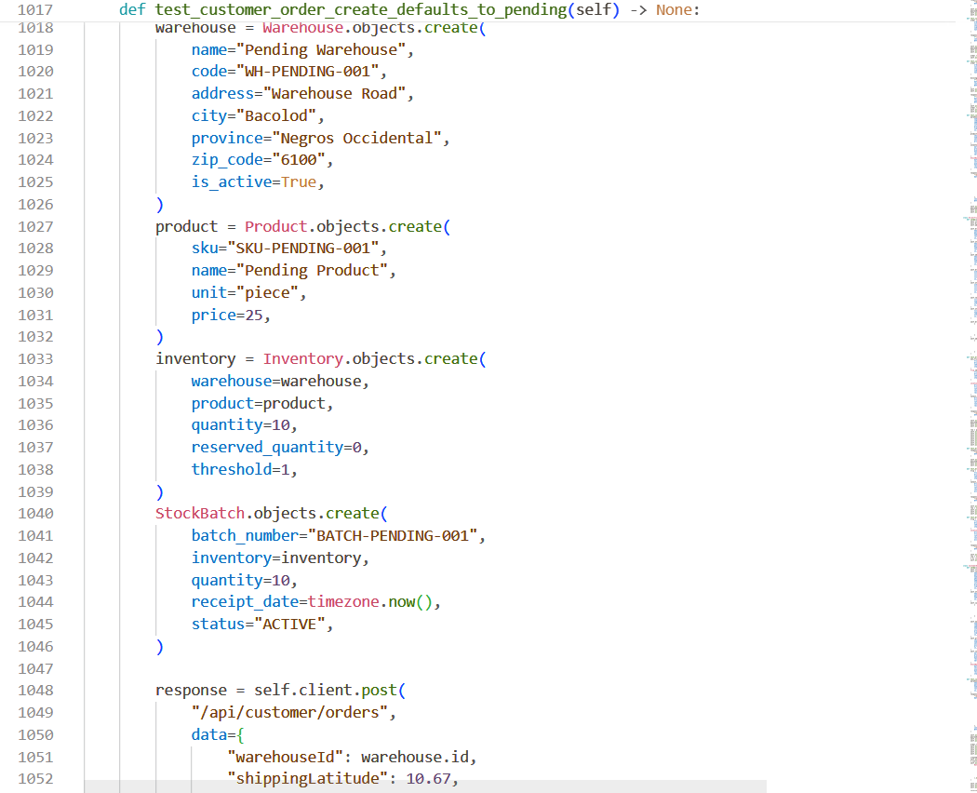
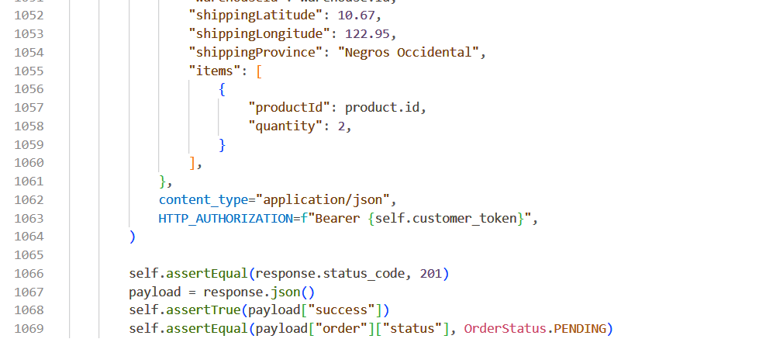
Figure 21: TC-WOrder01 - Default Customer-Order Status

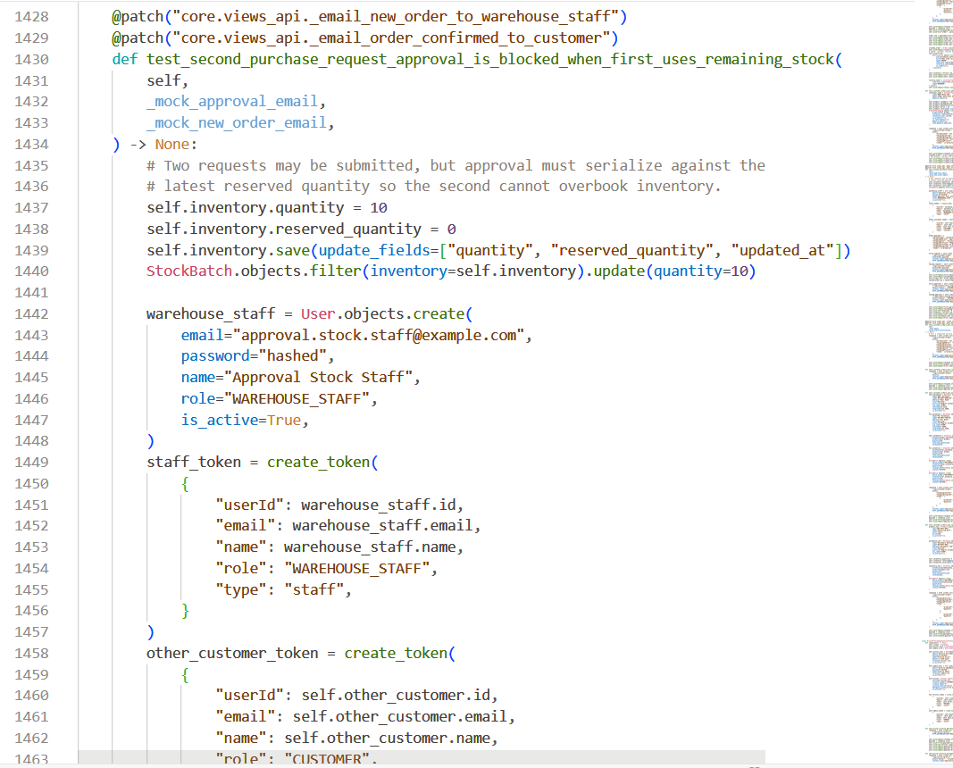
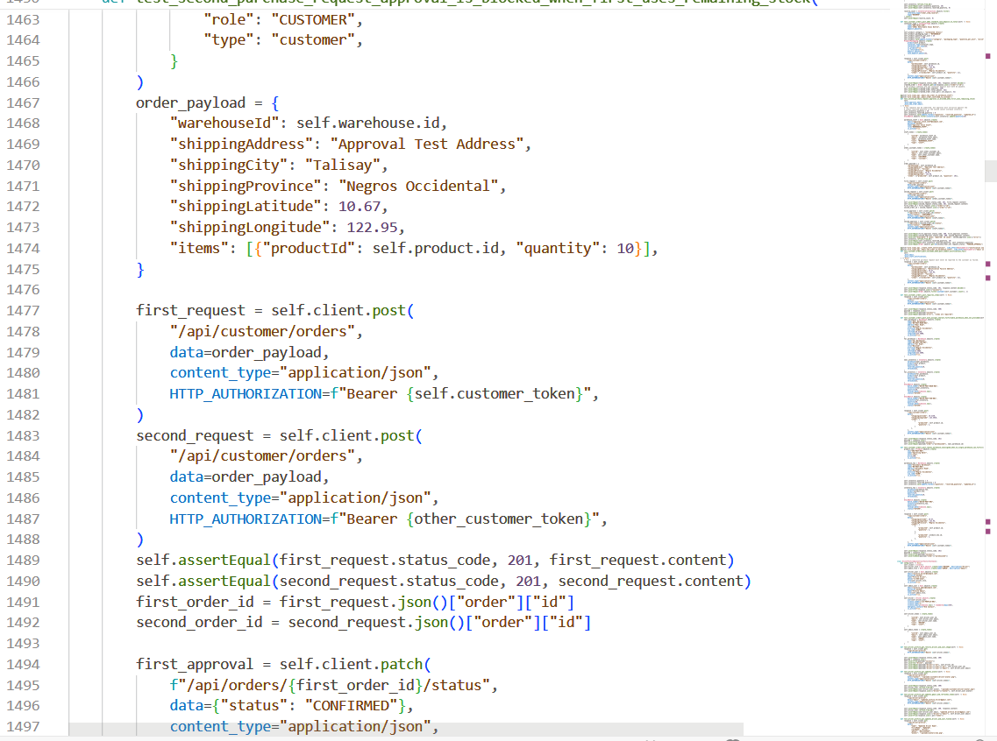
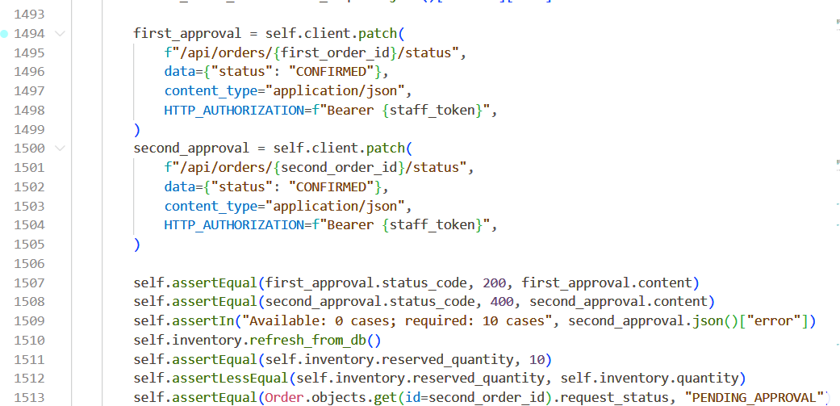
Figure 22: TC-WOrder02 - Competing Stock Approval

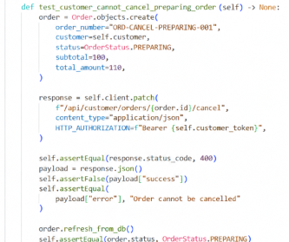
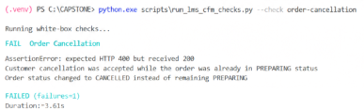

Figure 23: TC-WOrder03 - Cancellation Lifecycle Guard Failure

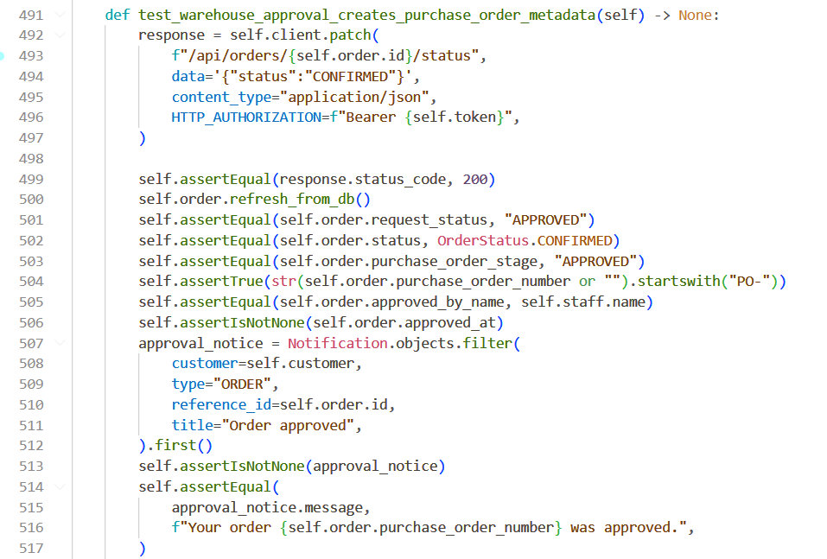
Figure 24: TC-WOrder04 - Purchase-Request Approval

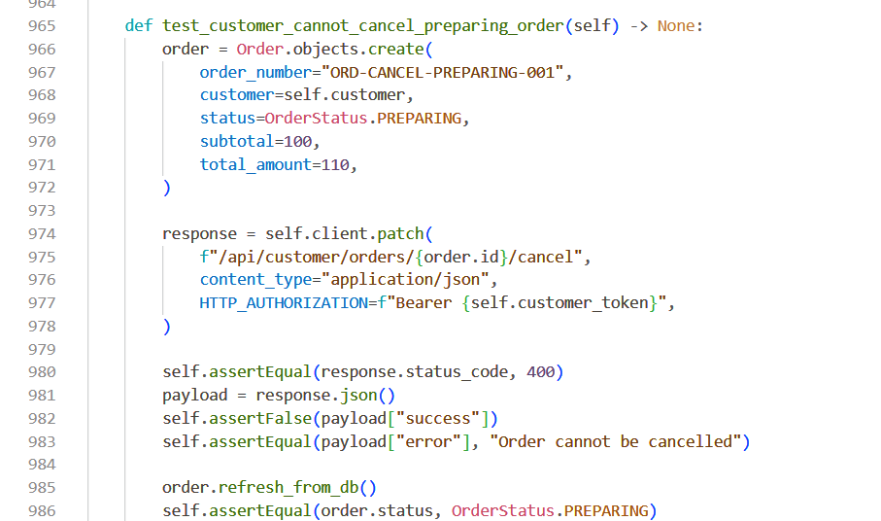
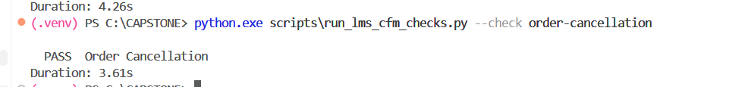
Figure 25: TC-WOrder05 - Purchase-Request Rejection

Evidence 6: White-Box Testing of the Alpha Testing of Transportation Management Functions
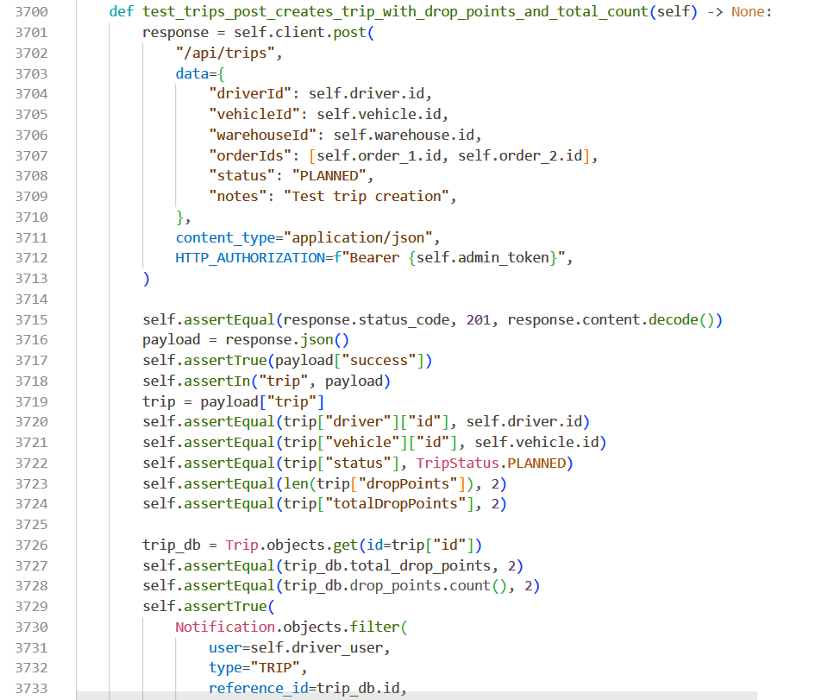
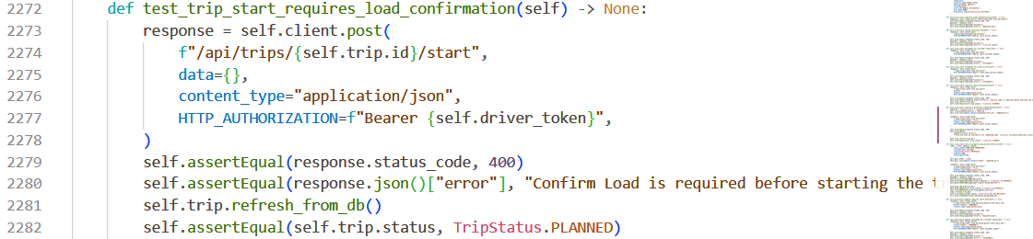
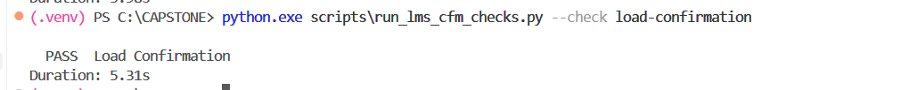
Figure 26: TC-WTrans01 - Delivery-Trip Creation

Figure 27: TC-WTrans02 - Load-Confirmation Requirement

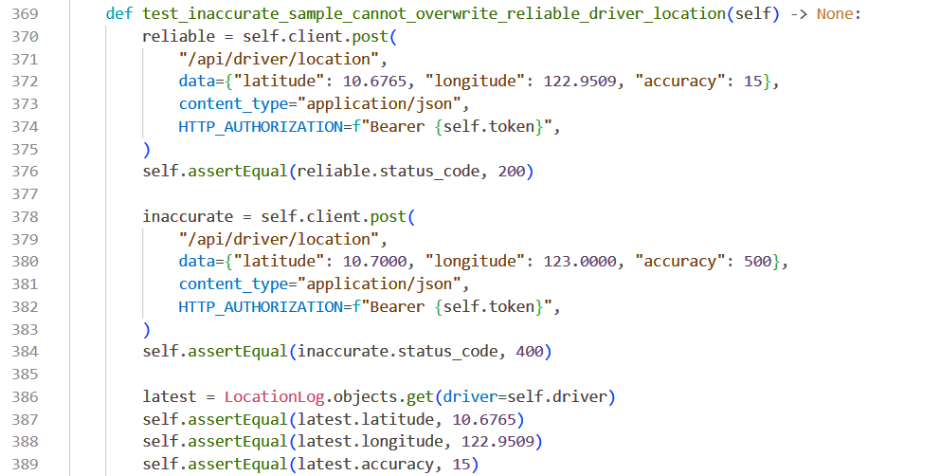
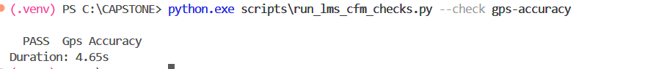
Figure 28: TC-WTrans03 - GPS-Accuracy Validation

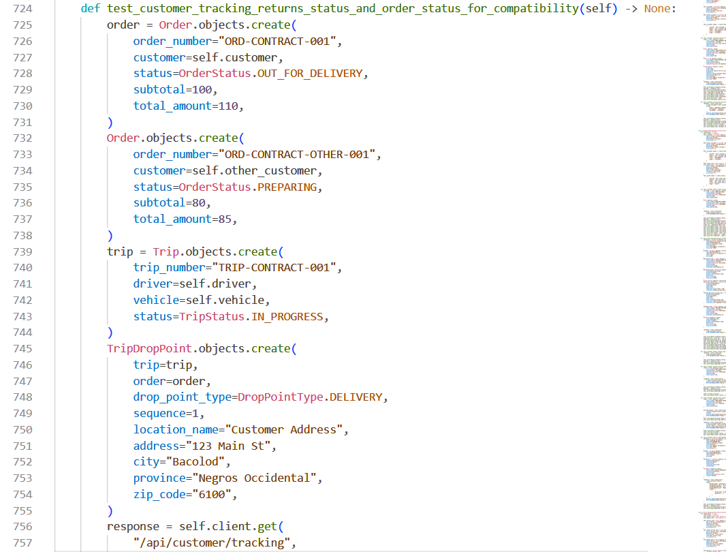
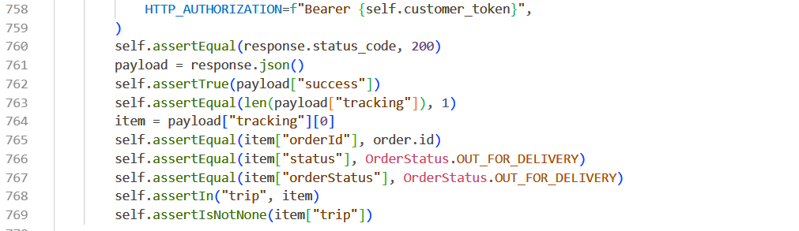
Figure 29: TC-WTrans04 - Customer Delivery Tracking

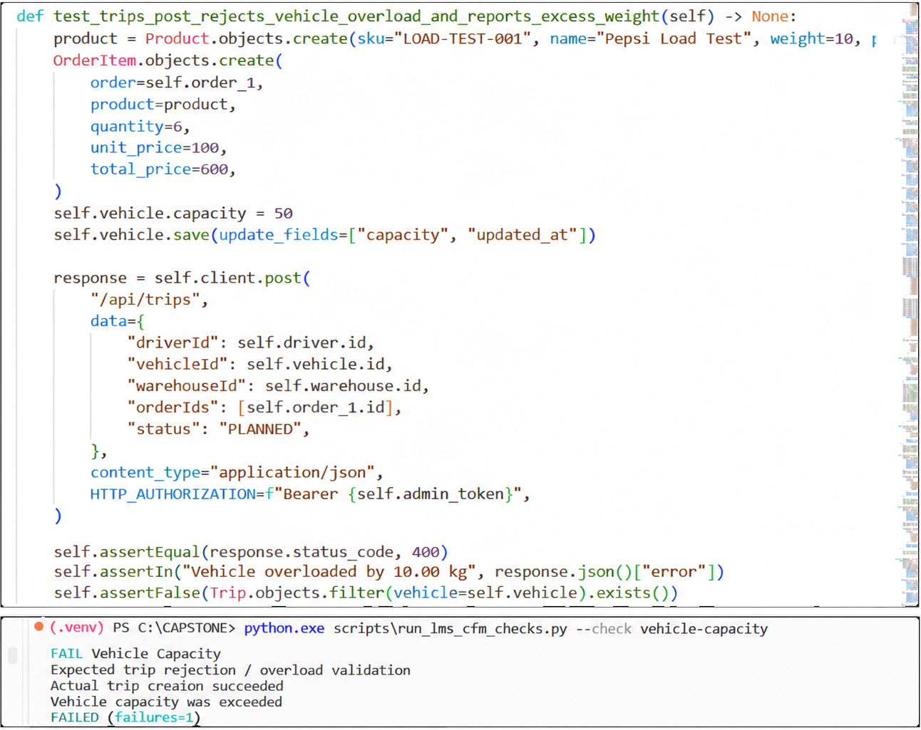
Figure 30: TC-WTrans05 - Vehicle-Overload Prevention Failure

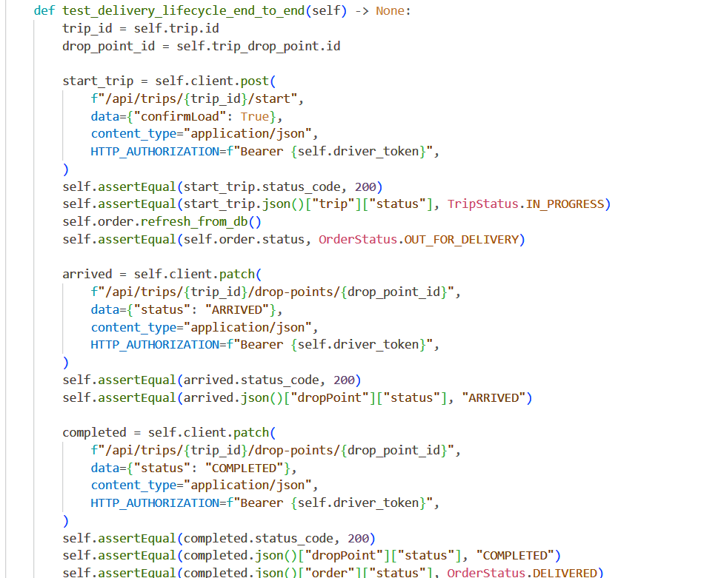
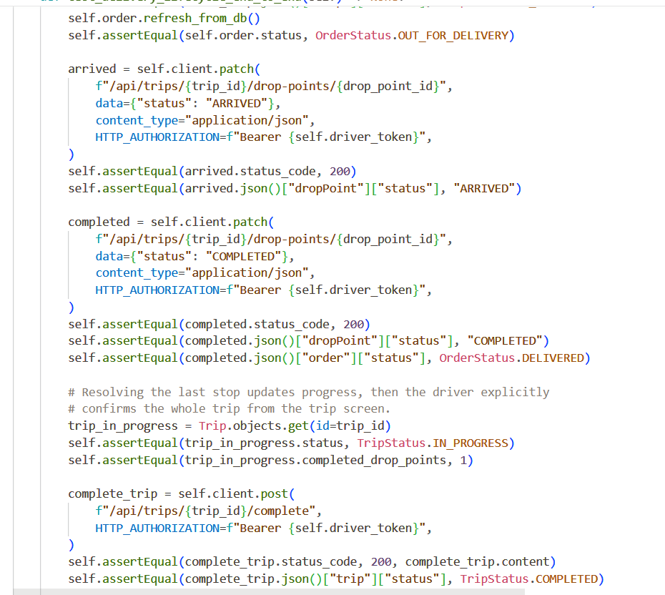
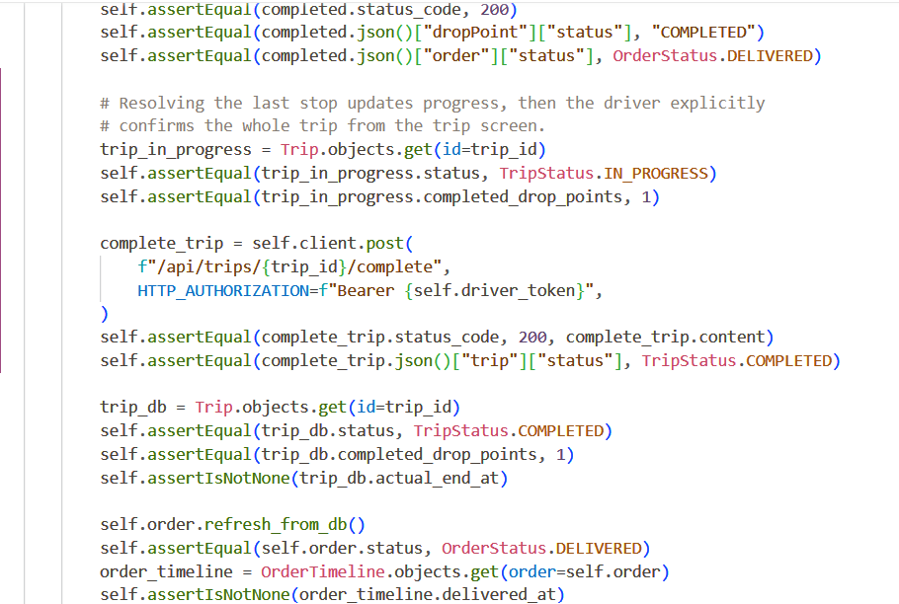
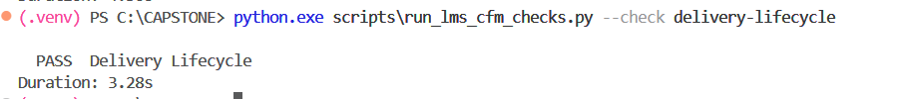
Figure 31: TC-WTrans06 - Complete Delivery Lifecycle

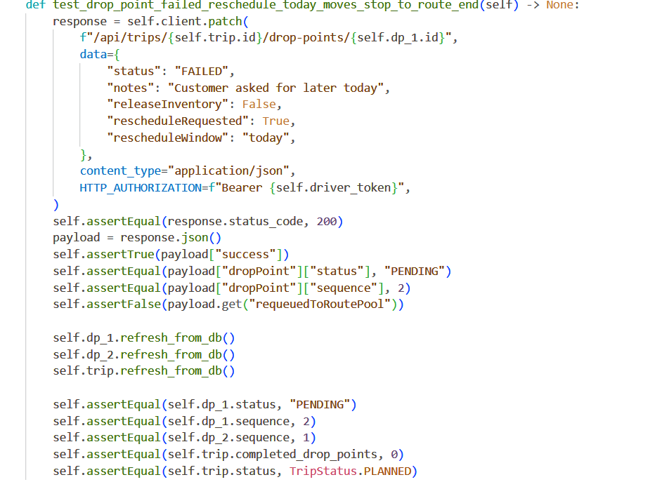
Figure 32: TC-WTrans07 - Failed-Delivery Rescheduling

Evidence 7: White-Box Testing of the Alpha Testing of Replacement Handling Functions
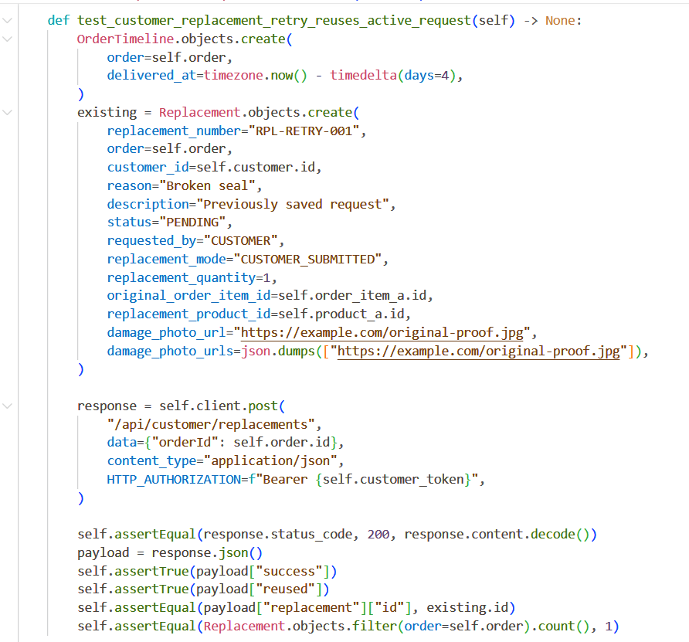
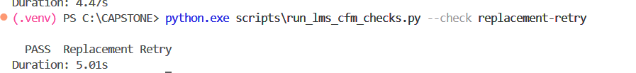
Figure 33: TC-WRepl01 - Replacement-Request Retry

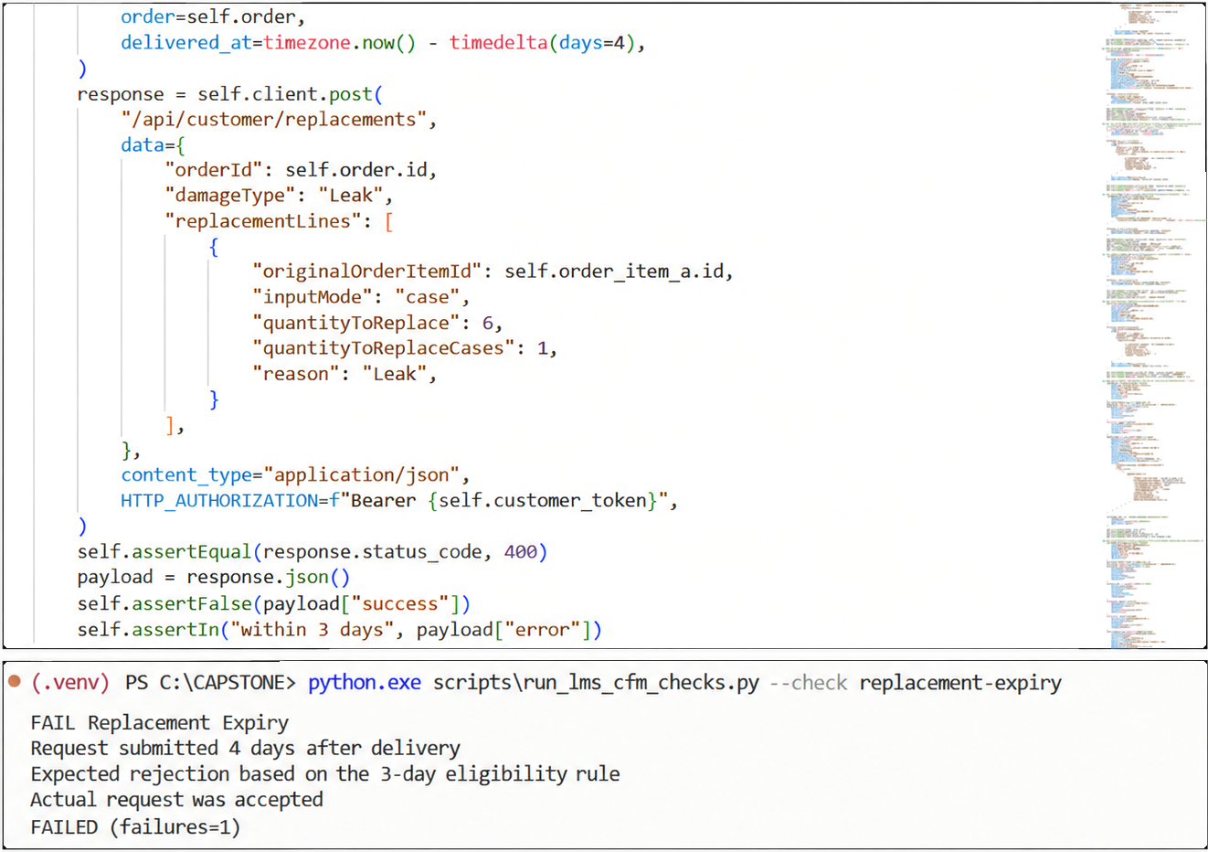
Figure 34: TC-WRepl02 - Replacement Eligibility Period Validation Failure

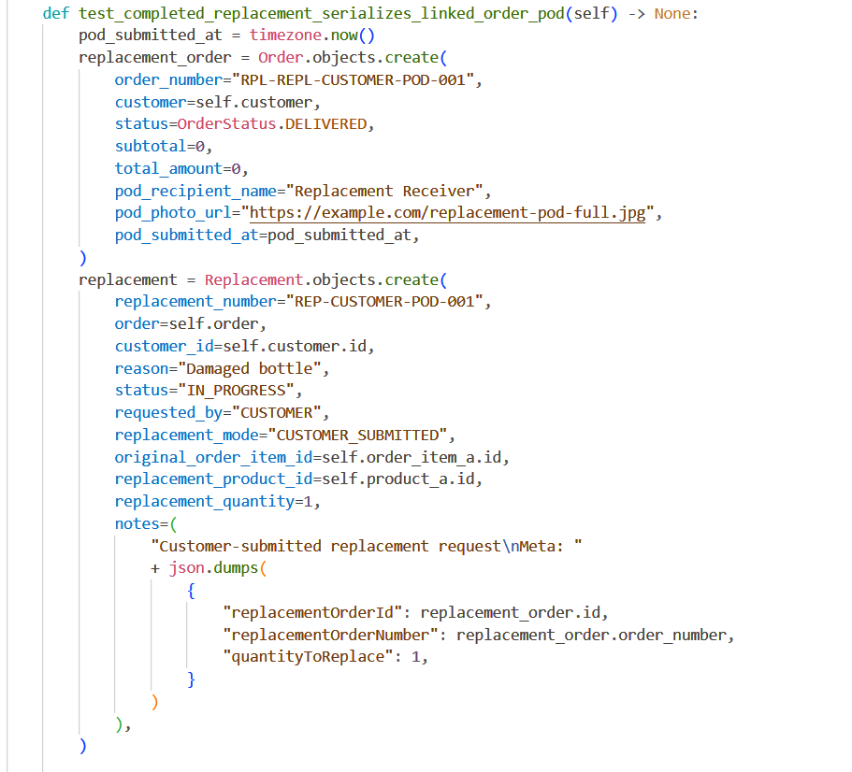
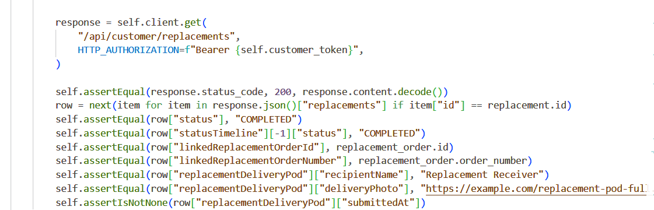
Figure 35: TC-WRepl03 - Replacement POD Evidence

Evidence 8: White-Box Testing of the Alpha Testing of Feedback Management Functions

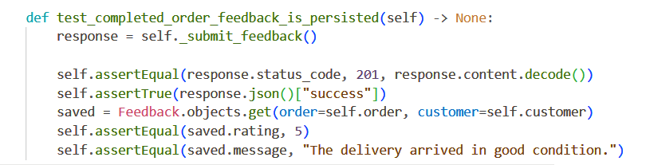
Figure 36: TC-WFeed01 - Completed-Order Feedback

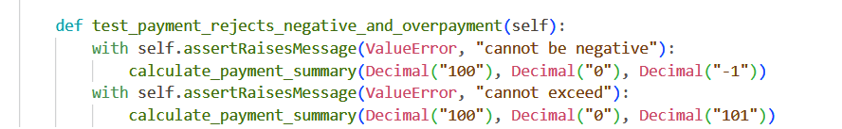

Figure 37: TC-WRetail03 - Payment-Bound Validation and Successful Test Execution

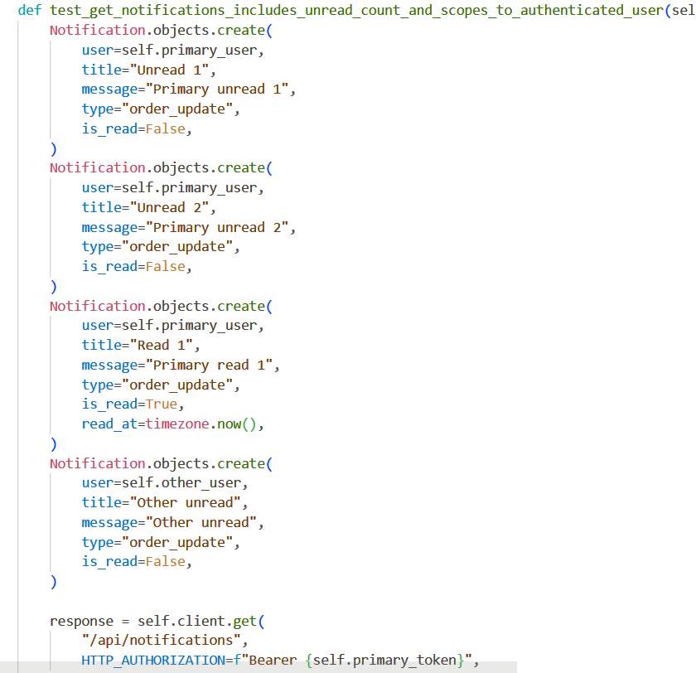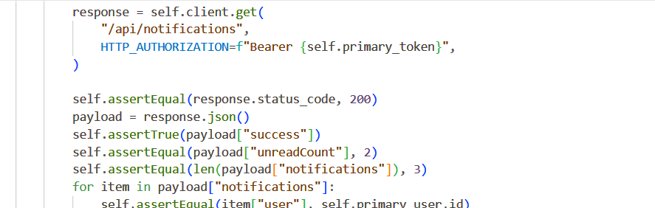
Figure 38: TC-WNotif01 - Notification-Account Isolation and Successful Test Execution

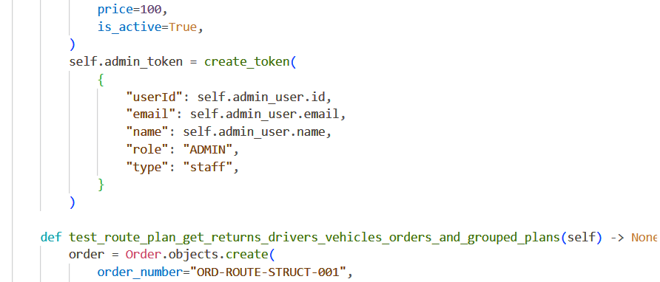
Figure 39: TC-WUpload02 - Upload-Content Validation and Successful Test Execution

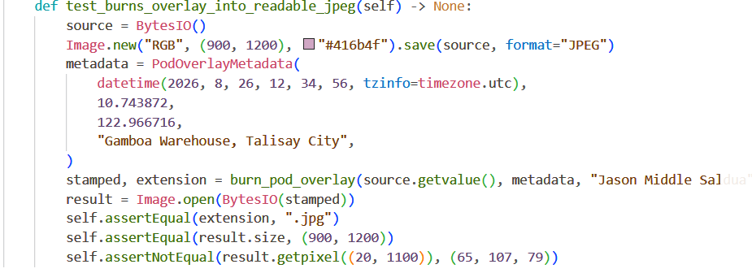
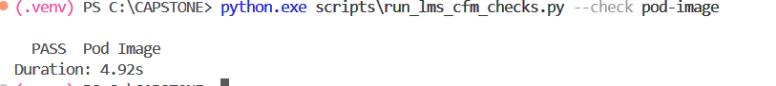
Figure 40: TC-WPOD01 - POD Image Overlay and Successful Test Execution

Evidence 9: White-Box Testing of the Alpha Testing of Report Generation Functions
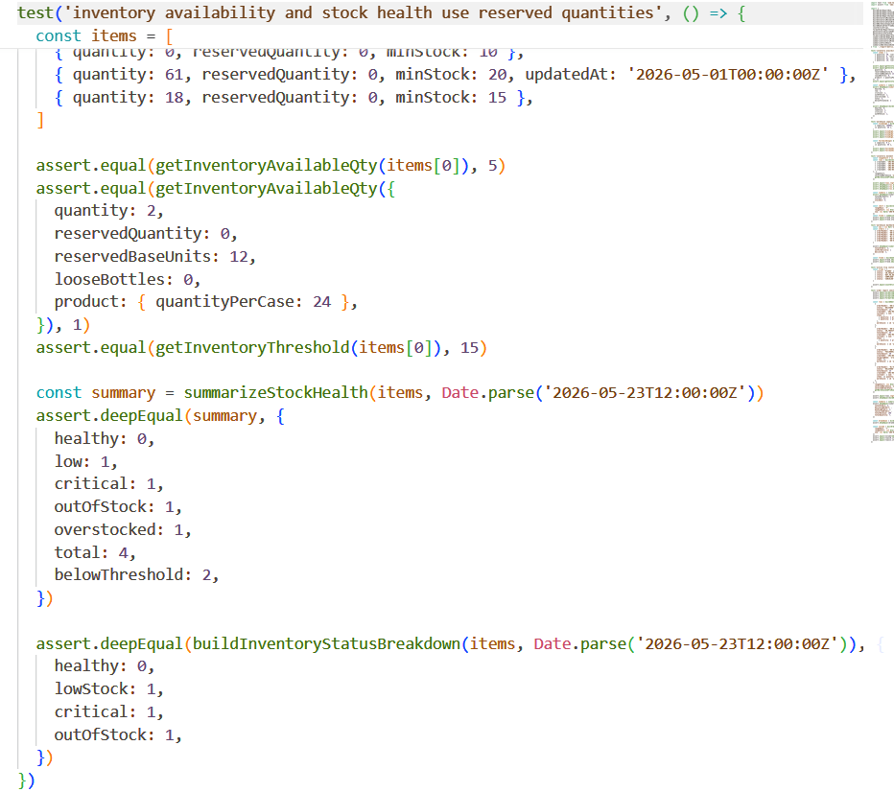
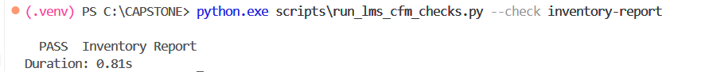
Figure 41: TC-WReport01 - Inventory Stock-Health Report
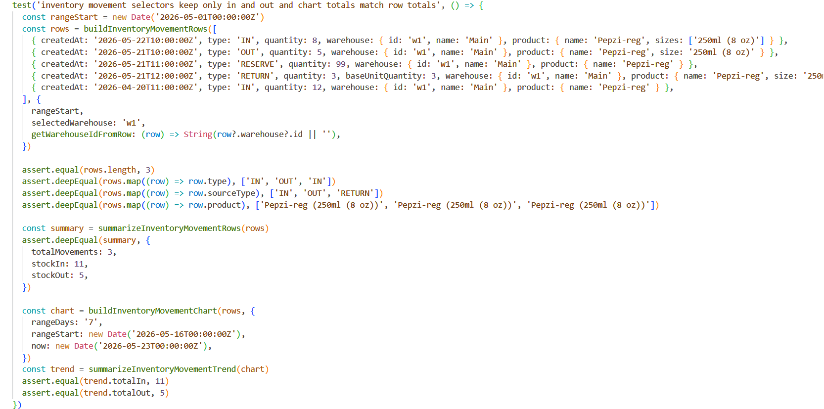
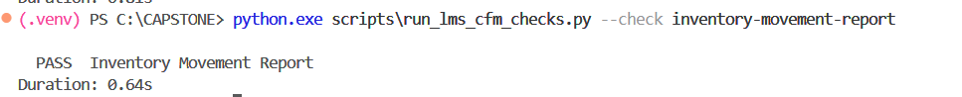
Figure 42: TC-WReport02 - Inventory-Movement Report
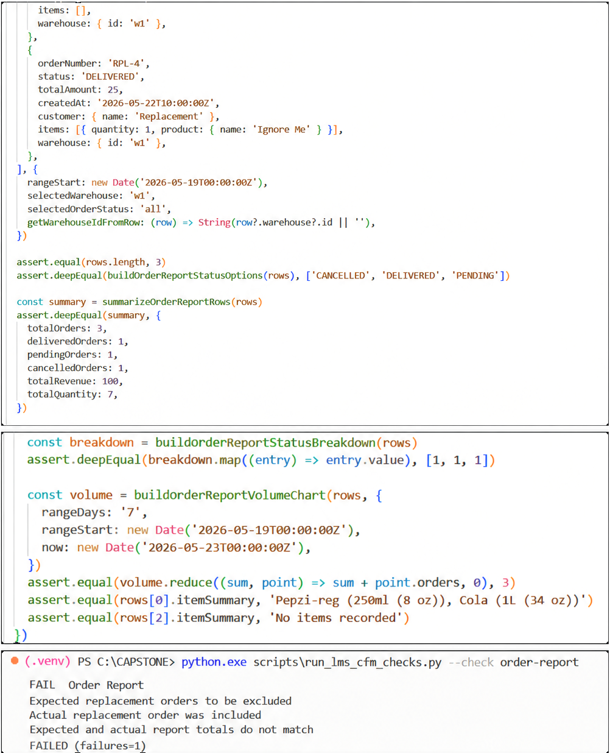
Figure 43: TC-WReport03 - Replacement Order Exclusion Failure

Summary of White-Box of the Alpha Testing Results:

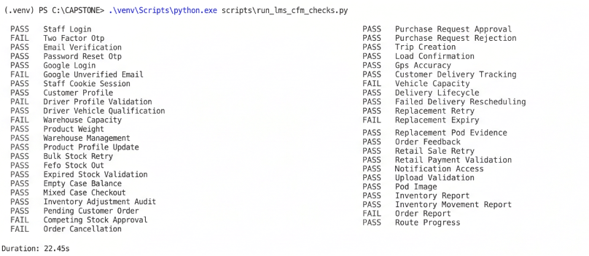
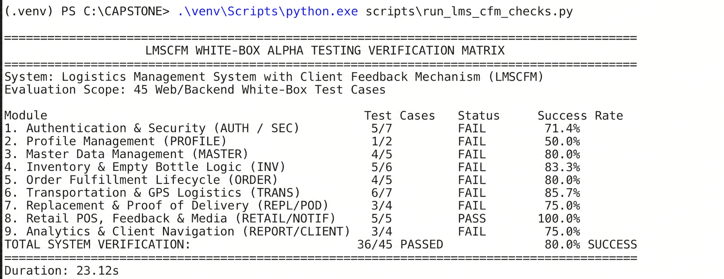

PYTEST EVIDENCE FOR 44 TEST CASES
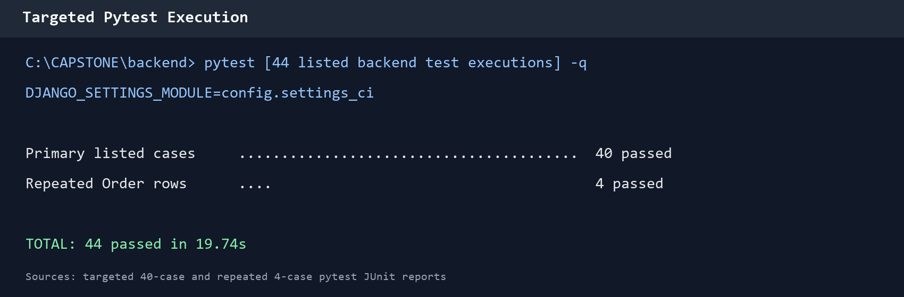
Figure 44: Focused pytest execution for the listed backend test cases
Results: All 44 listed backend test-case rows were executed and passed; four shared behaviors were rerun for their repeated Order table entries.
Category | Test Case ID | Test Description | Result
Authentication | TC-WAuth01 | Valid staff credentials | PASS
Authentication | TC-WAuth02 | Valid staff two-factor authentication | PASS
Authentication | TC-WAuth03 | Customer email verification | PASS
Authentication | TC-WAuth04 | Customer password reset | PASS
Authentication | TC-WAuth05 | Verified Google sign-in | PASS
Authentication | TC-WAuth06 | Unverified Google email rejection | PASS
Authentication | TC-WAuth07 | Staff-cookie session recovery | PASS
Profile | TC-WProfile01 | Customer profile update | PASS
Profile | TC-WProfile02 | Driver profile validation | PASS
Profile | TC-WProfile03 | Upload-content validation | PASS
Profile | TC-WProfile04 | Notification-account isolation | PASS
Master Data | TC-WMaster01 | Qualified driver-vehicle assignment | PASS
Master Data | TC-WMaster02 | Warehouse-capacity validation | PASS
Master Data | TC-WMaster03 | Server-side product-weight calculation | PASS
Master Data | TC-WMaster04 | Warehouse registration and profile update | PASS
Master Data | TC-WMaster05 | Product profile and weight update | PASS
Inventory | TC-WInv01 | Bulk stock-in idempotency | PASS
Inventory | TC-WInv02 | FEFO stock allocation | PASS
Inventory | TC-WInv03 | Expired stock-in prevention | PASS
Inventory | TC-WInv04 | Empty-case balance | PASS
Inventory | TC-WInv05 | Mixed-case checkout idempotency | PASS
Inventory | TC-WInv06 | Stock-batch adjustment synchronization | PASS
Inventory | TC-WInv07 | Competing stock approval | PASS
Inventory | TC-WInv08 | Cancellation lifecycle guard | PASS
Inventory | TC-WInv09 | Purchase-request approval | PASS
Inventory | TC-WInv10 | Purchase-request rejection | PASS
Inventory | TC-WInv11 | Immediate-sale idempotency | PASS
Orders | TC-WOrder01 | Default customer-order status | PASS
Orders | TC-WOrder02 | Competing stock approval | PASS
Orders | TC-WOrder03 | Cancellation lifecycle guard | PASS
Orders | TC-WOrder05 | Purchase-request approval | PASS
Orders | TC-WOrder06 | Purchase-request rejection | PASS
Transportation | TC-WTrans01 | Delivery-trip creation | PASS
Transportation | TC-WTrans02 | Load-confirmation requirement | PASS
Transportation | TC-WTrans03 | GPS-accuracy validation | PASS
Transportation | TC-WTrans04 | Customer delivery tracking | PASS
Transportation | TC-WTrans05 | Vehicle-overload prevention | PASS
Transportation | TC-WTrans06 | Complete delivery lifecycle | PASS
Transportation | TC-WTrans07 | Failed-delivery rescheduling | PASS
Transportation | TC-WTrans08 | POD image overlay | PASS
Replacement | TC-WRepl01 | Replacement-request retry | PASS
Replacement | TC-WRepl02 | Replacement eligibility period | PASS
Replacement | TC-WRepl03 | Replacement POD evidence | PASS
Feedback | TC-WFeed01 | Completed-order feedback | PASS

